General health check-up of school going children

The Dept of KAUMARBHRITYA with the Intention of making outreach services to the society, has taken up the general health check-up camp to a school going children with targeted school on Date: 29-03-2021, Monday at 11am to 2pm.
Place: Shree Ramakarunanada shikshana samsthe, English medium high school, Binkadakatti.
Target group: Children of 11-15 years of age, enrolled in classes 6th to 10th in the school.
Aim: improving the overall quality of children by enabling a systemic approach to child health screening and early intervention.
Objectives:
By the end of General health check-up of school going children, we should do
- Early detection of diseases.
- Educate regarding personal hygiene.
- Detect developmental delays including disabilities.
- Mental health Counselling
Achieved by this camp and Screened during camp
- Deficiencies
- Defects
- Childhood diseases
- Developmental delays and disabilities
- Beneficiaries 150 Students were examined and screened in the camp.
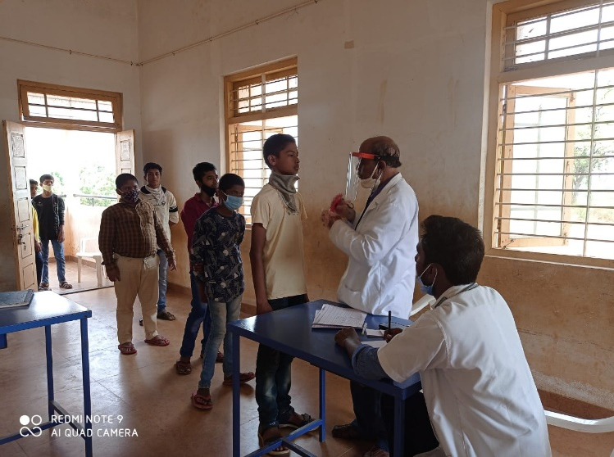

General examination and screening of children during camp by
Dr. N.S. Hadli
Associate professor

Dept. of Koumarbhritya

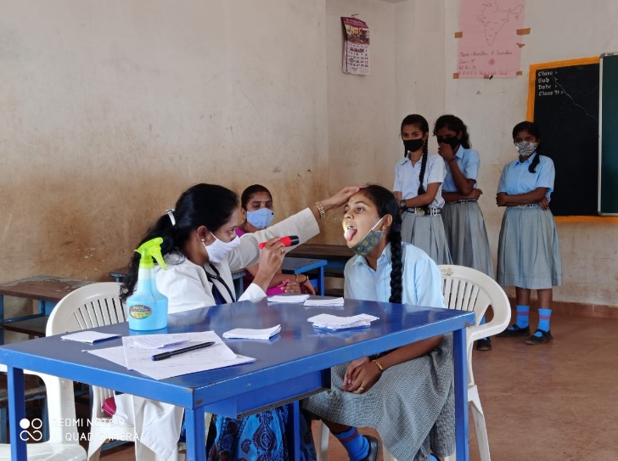

General examination and screening of children during camp by
Dr. Ashwini.B
Assistant professor
Dept. of kaumarabhritya

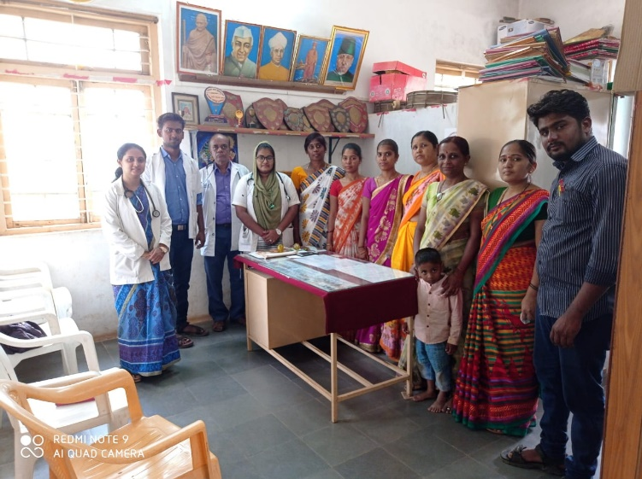

Staff members of Shree Ramakarunanada shikshana samsthe, English medium high school, Binkadakatti.

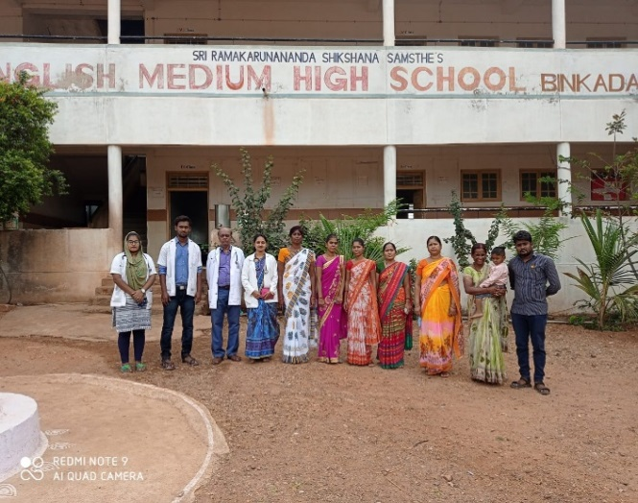

Camp conducted team and Staff members of Shree Ramakarunanada shikshana samsthe’s, English medium high school, Binkadakatti.

